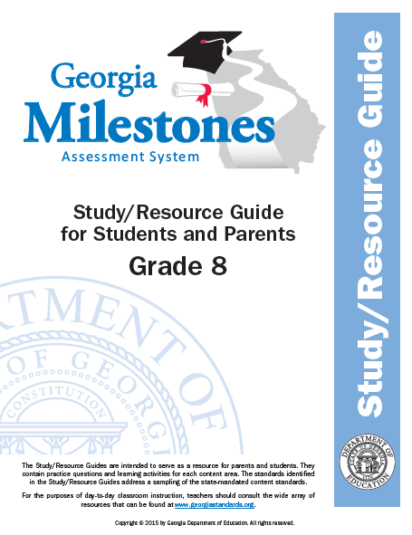

8th Grade GSE Math Student Study Guide 2016

Unit 1 - Transformations, Congruence, and Similarity (Important Tips)
- Two congruent figures have the same size and shape. Two similar figures have the same shape and angle measures. The length of each corresponding side is proportional to the original figure using a scale factor.
- A scale factor or factor of dilation that is greater than 1 will increase the size of the shape. A factor of dilation that is less than 1 will decrease the size of the shape.

Item 1: Look at the graph of a line segment before and after a transformation occurred.
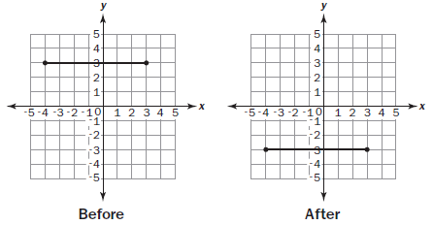

Which statement describes the transformation that could have been made on the line segment?
A. The line segment was dilated by a factor of ½ .
B. The line segment was rotated 180° counterclockwise about the origin.
C. The line segment was reflected over the x-axis.
D. The line segment was translated 6 units down and 1 unit left.

Item 2: Quadrilaterals ABCD, A′B′C′D′, and A"B″C″D″ are shown on the graph.
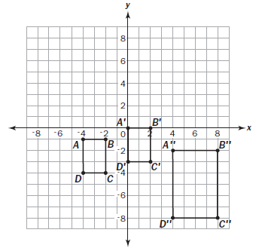
Part A: Describe a transformation or sequence of transformations to quadrilateral ABCD that would result in an
image quadrilateral with the coordinates A′(0, 0), B′(2, 0), C′(2, –3), and D′(0, –3).

Part B: A sequence of transformations to quadrilateral A′B′C′D′ that would result in an image quadrilateral A′B′C′D′, as
shown in the graph, starts with a dilation about the origin. This is followed by a horizontal and a vertical
translation. Name the horizontal and vertical translation.

Part C: What is the scale factor of the dilation described in Part B?

Part D: Is there another sequence of transformations that could result in the same coordinates? Explain your
reasoning.

Item 3: A line segment on a graph has endpoints of (–3, 1) and (3, 1). It is translated 5 units down and reflected across
the x-axis.
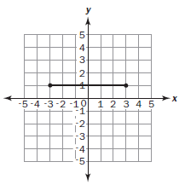
What are the endpoints after the series of transformations?
A. (–3, –4) and (3, 4) B. (–3, –1) and (3, –1) C. (–3, 4) and (3, 4) D. (–3, –6) and (3, –6)

Unit 2 - Exponents (Important Tip)
- Scientific notation is used to represent numbers that are very large or very small. The power of 10 can have a positive exponent to represent larger numbers. For example, 3 × 10³ = 3,000. The power of 10 can also have a negative exponent to represent smaller numbers. For example, 3 × 10ˉ³ = 3 • $\frac{1}{10³}$ = 0.003 .

Item 4: Between which two integers is the value of $\sqrt{21}$?
A. 0 to 1 B. 4 to 5 C. 6 to 7 D. 10 to 11

Item 5: A grain of sand has a mass of approximately 6 × 10ˉ² grams. Earth has a mass of approximately 6 × 10²⁸ grams.
How many times smaller is the mass of the grain of sand than the mass of Earth?

A. 1 × 10ˉ⁵⁴ B. 1 × 10ˉ¹⁴ C. 1 × 10²⁶ D. 1 × 10³⁰

Item 6:
Part A: Write the expression 7ˉ³ • 7⁶ as a fraction or integer.
Part B: Explain how you found your answer.

Unit 3 - Geometric Applications of Exponents (Important Tips)
- The value cubed is the inverse operation of the cubed root, and a value squared is the inverse operation of a square root.

Item 7: Jenna wants to hang outdoor stringed lights on her house along the roof line and horizontally across, connecting
the ends of the roof line to create a triangle.
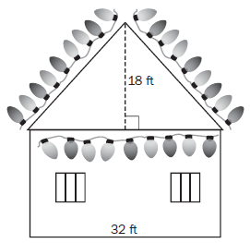

What is the approximate total length, in feet, of lights that she needs to create one triangle?
A. 48 feet B. 64 feet C. 80 feet D. 98 feet

Item 8: For a classroom party, there are 12 bottles of fruit punch. Each bottle is filled with 850 cubic centimeters of
punch. The fruit punch will be served in cone-shaped paper cups that are 7 centimeters across and 12
centimeters tall. How many completely full cone-shaped cups of the punch can be poured?

A. 16 B. 66 C. 232 D. 265

Item 9: Look at the right triangle on the coordinate grid.
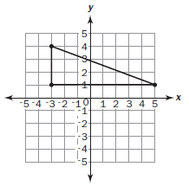
What is the length of the hypotenuse? A. $\sqrt{11}$ units B. $\sqrt{24}$ units C. $\sqrt{55}$ units D. $\sqrt{73}$ units

Unit 4 - Functions (Important Tip)
- When listing the domain and range of a relation, list each x-coordinate value for the domain without duplicating numbers. List each y-coordinate value for the range without duplicating numbers.
- In a list that contains a repeated domain value that is paired with more than one range value, the relation is not a function. This is true because the input, or x-coordinate value, has produced more than one output, or
y-coordinate value.

Item 10: Which of these functions has a greater rate of change than the function y = 5.6x + 7?
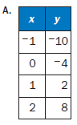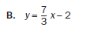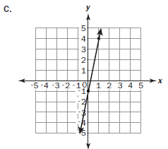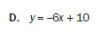

Item 11: Consider the four tables of values.

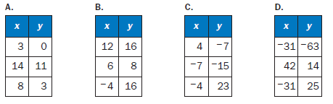

Part A: Which table models a relationship that is NOT a function?

Part B: Why is the relationship in the answer to Part A NOT a function? Explain your reasoning.

Item 12: Consider the table of values and the equation, which both represent a function.
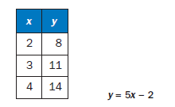
Part A: Which function has the greater rate of change?

Part B: Explain how you found your answer.

Unit 5 – Linear Functions (Important Tips)
- A straight line continues at the same steepness, or slope, through its entire length. The measure of the slope is the same between any two points on the line. (EE.6)
- The slope of the side lengths will remain the same between similar triangles. This can be proven using the endpoints of corresponding sides to determine and compare the slopes.
- Linear function: A function that produces a straight line when graphed on the coordinate plane. The linear function can be written as an equation in slope-intercept form.
- y = mx: the slope-intercept form of a line going through the origin, where m represents the slope.
- y = mx + b: the slope-intercept form of a line that crosses the y-axis at b, where m represents the slope.
- A straight line on a coordinate plane can be vertical, horizontal, or diagonal.
- The slope of a line can be determined using any two points on the line by writing the ratio of the vertical rise to the horizontal run. The ratio written as a fraction can then be reduced to represent the slope if necessary. For example, a line going through the points (1, 2) and (9, 6) has a slope of $\frac{4}{8}$, which can be reduced to $\frac{1}{2}$ .

Item 13: Which equation represents a nonlinear function?

A. y = 3x³ B. 3x + 2y = 10 C. y = 15.3 D. y = $\frac{1}{4}$x – 2

Item 14: Look at △ABC with coordinates A(–1, –1), B(2, 3), and C(2, –1).
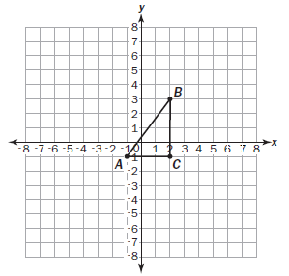

Part A: The ordered pair (5, y) defines the location of point F, which is on line AB. What is the value of y for this ordered
pair?

Part B: If you move 3 units to the right from point F, how many units up or down do you need to move in order to stay
on line AB?

Item 15: Consider this graph that passes through points (0, 0) and (5, 30).

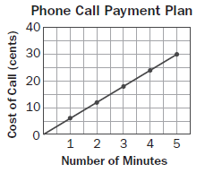

Which equation represents the cost of a phone call c after m minutes, according to the payment plan?
A. c = $\frac{1}{6}$m B. c = 6m C. c = $\frac{1}{30}$m D. c = 30m

Unit 6 – Linear Models and Tables (Important Tips)
- A pattern in the data set can be used to predict the outcomes of other variables.
- The relationship between values can be represented using tables, graphs, and equations using the slope and y-intercept.

Item 16: This table of values represents a linear function.
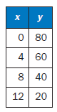

Part A: Is the rate of change of this function –5? Explain how you know.

Part B: What is the initial value of this function?

Item 17: Look at the scatter plot showing the relationship between the average daily temperature and the number of
visitors at a beach.
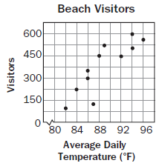

What is the pattern of association shown by the data?

A. no association B. positive association C. negative association D. nonlinear association

Item 18: Which straight line BEST fits the data for the scatter plot?
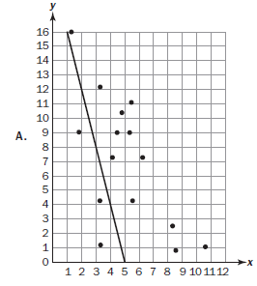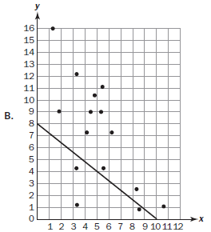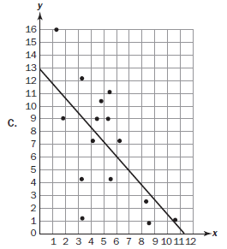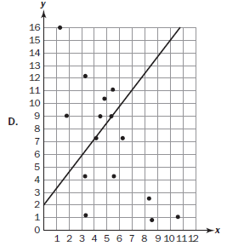

Unit 7 – Solving Systems of Equations (Important Tips)
- The number of solutions to a system of equations can be no solution, one solution, or multiple solutions, including an infinite number of solutions.

Item 19: Consider this system of equations: –7x + 8y = 1
4x – 8y = 20
What is the y-coordinate of the solution for this system?
A. –1 B. –6 C. 1 D. 6

Item 20: Consider this system of equations: y = -2x - 1
y = $\frac{1}{2}$x + 4
Which graph represents the solution of the system?
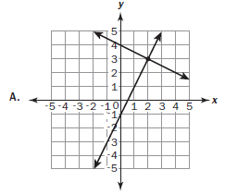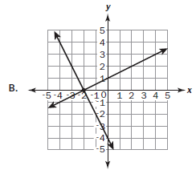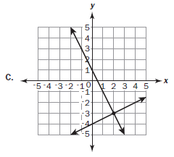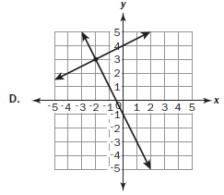

Item 21: Which system of equations has exactly one solution?

A. 5x – y = –3
5x – y = –2

B. 8x – 3y = –12
x – 3y = 9

C. 3x – y = 4
9x – 3y = 12

D. 2x – y = 3
2x – y = –4

8th Grade Answer Keys to Items #1-21:

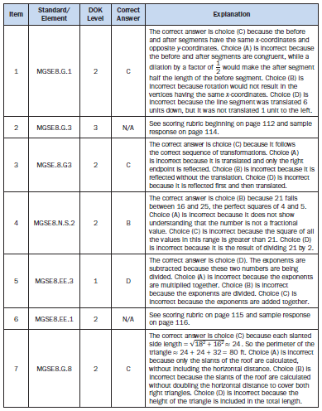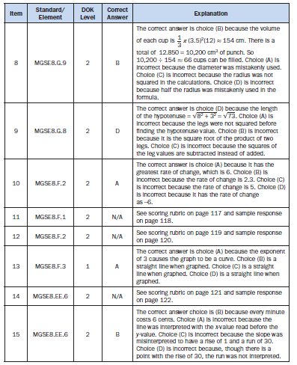
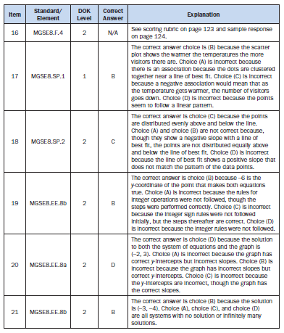

Item 2:
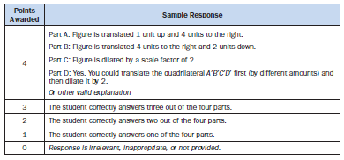
Item 6:
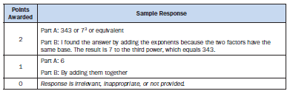
Item 11:
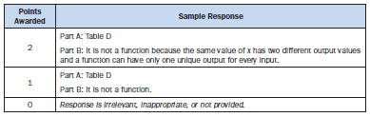
Item 12:
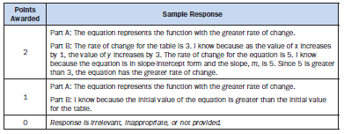
Item 14: 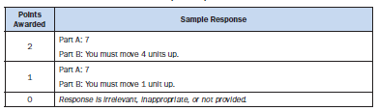
Item 16:
